4.4.1 Prompting Evaluation
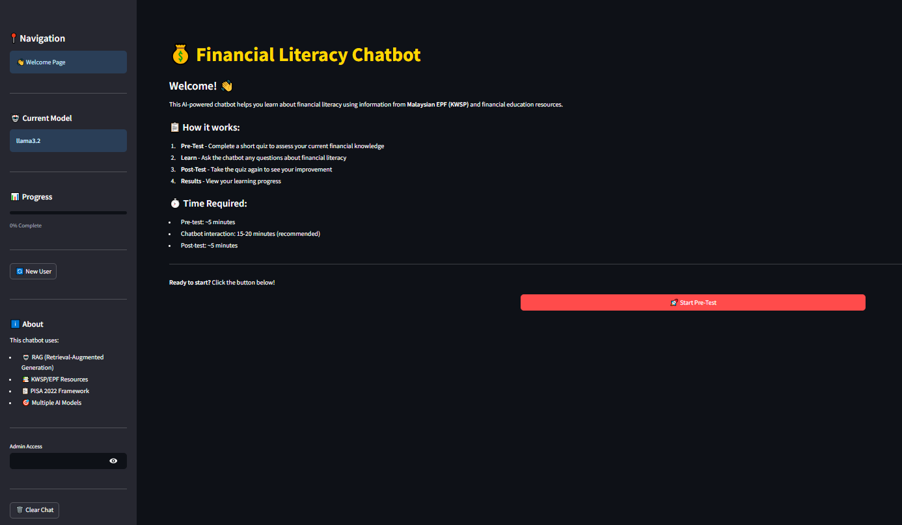
The welcome interface is the point of entry of the system, as it presents the users with the purpose and the workflow of the financial literacy chatbot. As shown in Figure 4.XX, the page has a clear title, which is Financial Literacy Chatbot, and the description is brief, as it states that the system is aimed at supporting the financial learning process based on the information found in the Malaysian EPF (KWSP) resources and financial education materials. This introduction is very brief to keep down the mental capacity required but at the same time so that the users are aware of the scope and purpose of the system.
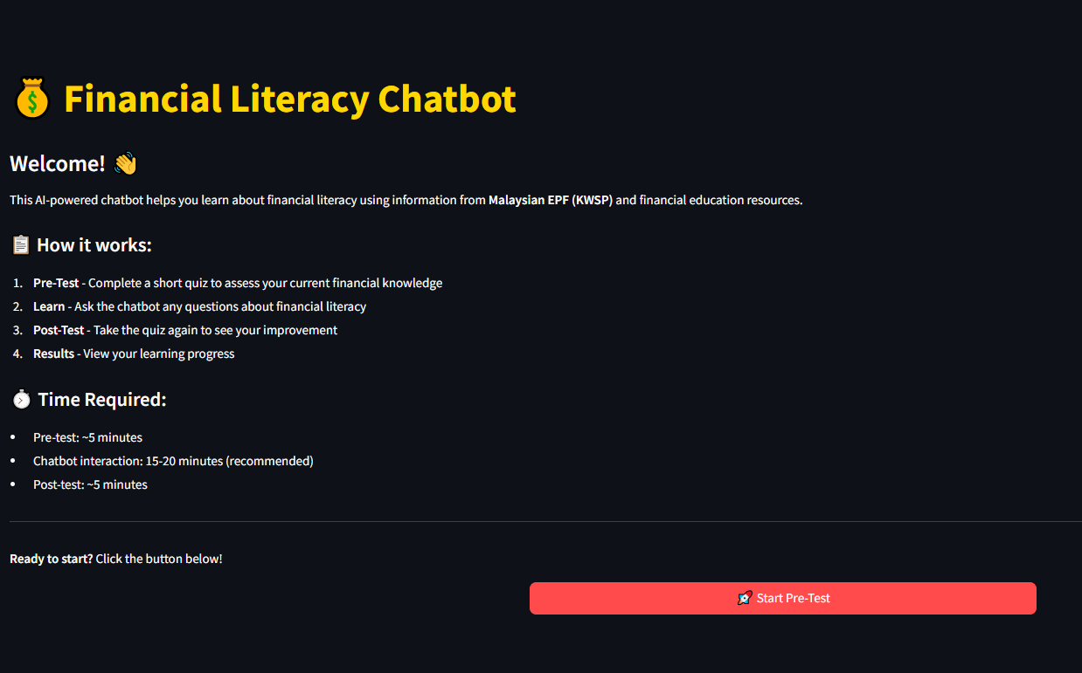
The interface provides a system of carefully planned learning steps comprising of four major steps (1) pre-test, (2) chatbot interaction, (3) post-test, and (4) review of the results. These actions are clearly enumerated as in a section that has been labelled as “How it works”, so that the users are able to form a mental picture of how the process works before interacting with the system. Time estimates are also introduced to control the expectations of the users and motivate them to complete the process, which is especially necessary with student users and first-time participants.
On the left panel are positioned elements of navigation, such as indicators of the current model in use, progress status, and administrative access. Such sidebar design promotes uniformity of the system pages and allows a user to determine their position in the workflow. There is a high-profile Start Pre-Test button that directs the users to the next step, which is the assessment.
In design, dark interface theme has better visual comfort when interacting over a long period of time and icons and section headers make the process more readable. Overall, this entry interface creates an organized, intuitive and user-friendly entry point that corresponds with the goal of the study which is to take users through the financial literacy assessment and learning process in a systematic manner.

4.2.2 Prompting Evaluation
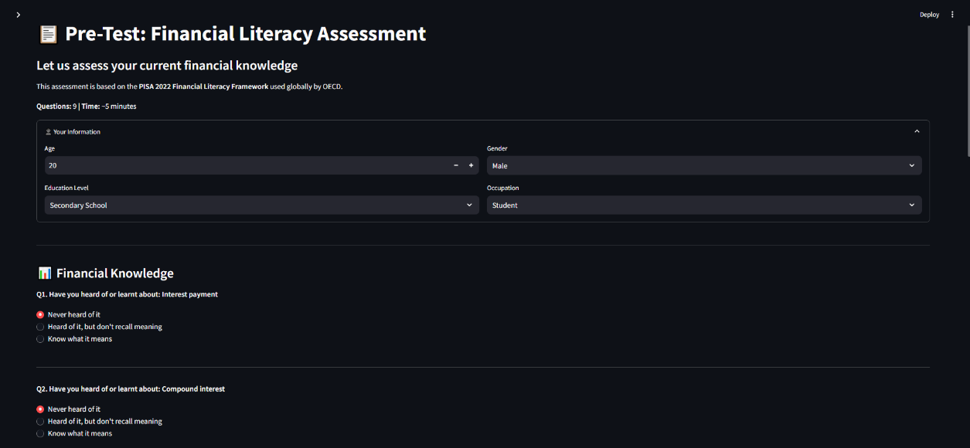
The pre-test interface will be designed in a way that assesses the first level of financial literacy of the users before being exposed to the chatbot. According to Figure 4.XX, the interface begins with a brief introduction, according to which the assessments will be based on the OECD PISA 2022 Financial Literacy Framework. This contextual coding enriches the scholastic skilfulness of the tool and makes the users understand that the questions were underpinned by internationally acknowledged guidelines.
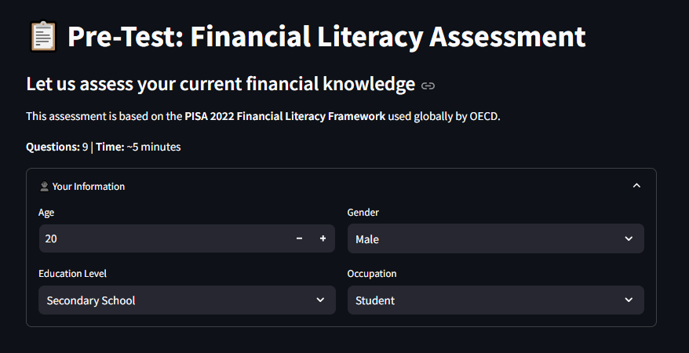
First, the interface collects some demographic data, including age, gender, educational level, and profession. These objects are displayed in a structured form structure using drop-down menu and numeric inputs and hence reduce any possible error of keying on the part of the user and retain the option of further aggregation and analysis. The obtained demographic data help to interpret the learning outcomes in a context and make sure that the personally identifiable information is excluded.
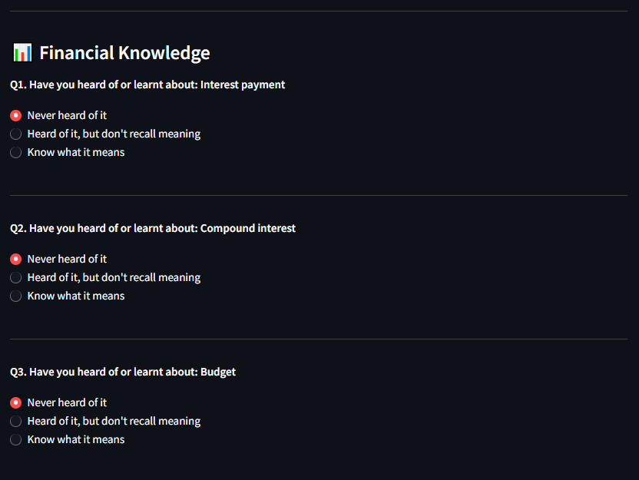

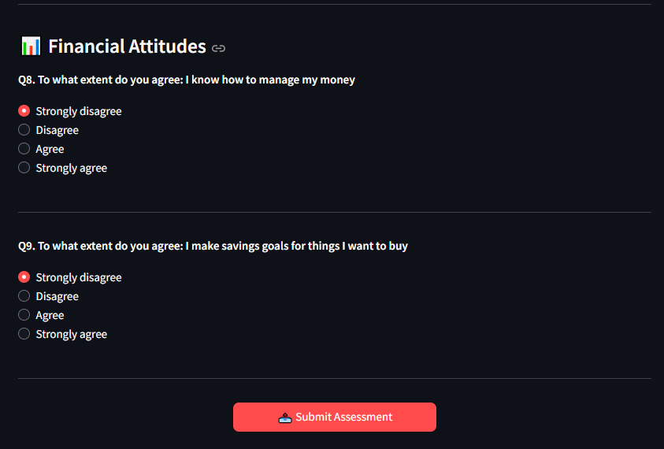

Next to the demographic part the respondents answer the financial knowledge questions. All categories are marked in a specific order and are arranged in thematic sections, e.g. Financial Knowledge. The possible responses are provided in multiple choice format with such options like Never heard in it, heard it but do not remember, and know what it means. This ordinal scale allows the generation of different levels of familiarity as opposed to binary correct/incorrect classification.
The interface design is simple and focused with the representation of one conceptual group at a time and uniform spacing and typography. Progress indicators can help users to track their progress level, and this helps in minimizing doubts and eases usability. Overall, the pre-test interface can be viewed as a diagnostic tool that provides a baseline level of financial knowledge and, thus, allows the following comparison with the post-test results to determine the learning gains that can be ascribed to the interaction with a chatbot.

4.2.2 Prompting Evaluation
The interaction interface of the chatbots is the critical learning environment in the system. Using a text-based communication interface, as shown in Figure 4.XX, users communicate with the chatbot through a simulated ubiquitous messaging system, and therefore the obstacles to engaging with the chatbot are reduced. The active model used to generate responses is also displayed through the interface (e.g. llama3.2), thus, increasing the level of transparency to the underlying language model used to generate responses.
The queries posted by the users are natural-language queries related to financial literacy, including conceptual explanations and practical financial scenarios. The chatbot provides structured and explanatory answers that can be understood by people with a limited background in financial knowledge. These reactions tend to have definitions, examples, and a step-by-step explanation thus, promoting conceptual understanding rather than memorization.
Conversational design is iterative because it allows users to ask follow-up questions or seek clarification. This form of interaction is in line with the principles of constructivist learning whereby learners actively create knowledge based on dialogic interactions. Regarding the usability, the input field is clearly separated in terms of system messages, and visual texts distinguish user queries and chatbot answers.
Also, the system offers the status indicator that will indicate the user is still engaged with the chatbot and hence the awareness of the active learning process. Despite the introduction of a large-scale language model to the chatbot to generate responses, its role in the interface is made to seem that of an educational assistant and not an authoritative decision-maker. The specified design option encourages responsible AI usage through the promotion of learning support rather than reliance.
Together, this interface turns the stage of learning in the framework into reality and allows the user to explore the subject of finance in an interactive nature and at a self-paced pace.

4.2.2 Prompting Evaluation
After the phase of chatbots interaction is finished, participants proceed to the post-test. The post-test interface is like that of the pre-test setup so that there is consistency in the set up and comparative analysis becomes easier. After the assessment process, the participants are provided with a results summary which is presented in a visual format indicating learning outcomes in numerous dimensions such as financial knowledge, behaviour, confidence and attitudes.
The system presents parallel Before and After values with percentages of improvements as shown in Figure 4.X.X. Such a comparative visualization will allow the participants to quickly identify the shifts in their performance after communication with the chatbot. An overall improvement indicator that is significantly displayed highlights the overall progress thus supporting the positive reinforcement of learning.
A clear typography and color-coded indicators are used to differentiate between the baseline and post-intervention scores in the presentation of the results. These visual displays help non-technical users to interpret their findings without the need to have statistical ability. In research perspective, these measures provide concrete data of learning outcomes hence justification of the research assessment goals.
In addition, motivational feedback like the Excellent progress messages is used, which are a confirmation message, which helps to boost the engagements and satisfaction of the learners. As a result, the results page serves as an evaluative and motivational experience, tunnelling the results of the evaluation to user experience.
This structure will make the learning results concrete and understandable, which will justify the purpose of the study to evaluate the effectiveness of the chatbot in promoting financial literacy.

4.2.2 Prompting Evaluation
The system will have a specific feedback interface that will allow users to review their experience after the learning process. As shown in Figure 4.X.X, the users are permitted to evaluate the helpfulness and ease of use using slider-type inputs, as well as provide open-ended textual feedback. This quantitative-qualitative approach helps provide a more in-depth range of information about the perception of the users.

Feedback is then stored and presented in an administrative dashboard, where an administrator can review aggregate numbers, separate entries, and timestamps. The statistics of the feedback are summarised in the dashboard, including the total count of feedback and the helpfulness indicators, which allows quickly monitor the reaction of users. Expandable entries allow being able to inspect them in more detail without overcrowding the interface.
The administrative perspective also presents the test participation history including both pre-test and post-test records that are connected to every user session. This is beneficial in providing transparency and ease in manual review to evaluate it. Notably, the dashboard focuses on monitoring, as opposed to automated decision-making and, therefore, it is interpretable and ethically controlled.
Through a blend of feedback and administrative opinions, the system allows refining the content and interface design through several iterations. This capability is in line with the research objective of testing the usability and perceived effectiveness, thus providing empirical data that is not limited to performance scores.

